**Concise Report – African Women Lawyers Association (AWLA) 2022 International Seminar**

Following the completion of the draft Strategic Plan document African Women Lawyers Association (AWLA), AWLA’s desire to improve deliverables, register measuring impact and the prevailing socio-economic situations across the African continent with Nigeria particularly going to the pools in 2023 for its country’s general election, AWLA convened an international seminar for all of its members all over the world.

The conference brought together AWLA members from across Africa and other parts of the world. The conference had both English-speaking and non-English-speaking participants. Although the process of translating into French and English Language was a challenge, it was non the less participatory.

The international President of AWLA, Barr. Mandy Asagba, welcome the participants and expressed her joy again at getting to meet the members again. She introduced Mr Chukwuemeka Onyebuchi, who has been engaged by AWLA as the organization’s technical consultant. Mr Chukwuemeka also led the AWLA team for the development of the AWLA Strategic Plan 2022 – 2027. AWLA identified five areas as its priority areas in the Strategic Plan:

1. Institutional Development
2. Community Development
3. Funding Development (Resource Mobilization)
4. Networking and Partnership; and rounded off with
5. Monitoring and Evaluation

**The process discussed the following**:

1. The AWLA Strategic Plan – 2022 – 2022

The facilitator took the participants through the draft strategic plan. Explaining African context as it relates to the socio-economic realities of women, girls and children across Africa while drawing comparisons and references from the Sustainable Development Goals (SD-Goals). AWLA identified *SD-Goals 1- No Poverty; 2 - Zero Hunger; 3- Good Health and Well-being; 4 - Quality Education; 5 - Gender Equality; 6 - Clean Water and; 8 - Sanitation; Decent Work and Economic Growth; 10 - Reduced Inequality; 16 - Peace and Justice Strong Institutions; 17 - Partnerships to achieve the Goal* as central to the AWLA vision and mission.

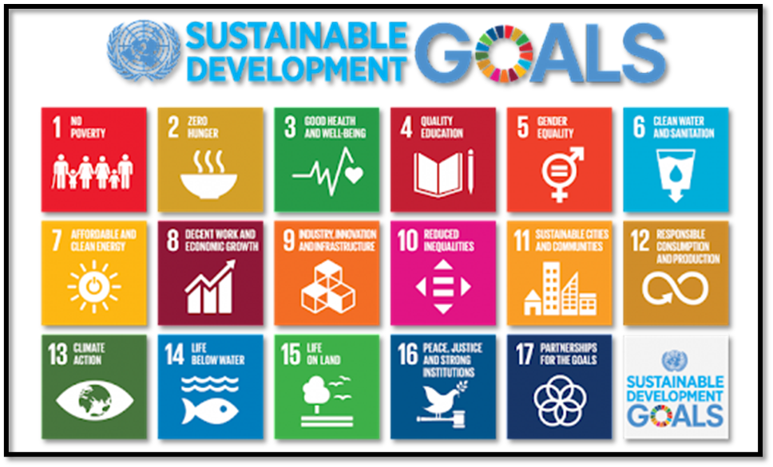

*The Sustainable Development Goals*

He also explained the AWLA core values as articulated in the SP document while illustrating how the AWLA vision and mission statements are pivotal to fulfilling the AWLA dream. The AWLA vision is the desired situation that all AWLA country chapters in Africa and in the diaspora envision for women, girls and children across Africa. The AWLA mission is the strategic assignment that AWLA must embark on to achieve the vision.

**AWLA Vision Statement** – *AWLA envisions a future without indignity against women and children*

**AWLA Mission Statement** - *To promote human rights, especially for women, children and the vulnerable; fight for the protection of all to promote human dignity as enshrined by the local, national and international laws*.

AWLA's core values are the guiding principles through which AWLA implements and intervents in its socio-economic responses across Africa and the diaspora Chapters:

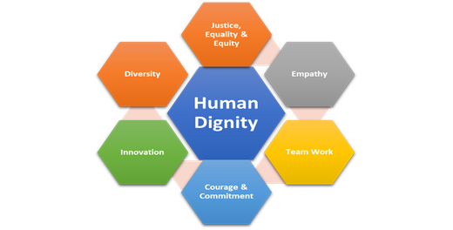

*AWLA Core Values*

1. AWLA publicity and visibility (Social Media and online presence)

AWLA cannot afford to operate multiple social media accounts or websites that are disintegrated/ or not in sync with its parent body . There should be central AWLA social media accounts across the social media platform. All country chapter social media accounts must serve AWLAl social media account. Funding partners and other interested parties are also on the lookout to avoid working with organizations which conflict with themselves.

AWLA must have one website CLEARLY marked as AWLA. A country chapter website must also be so clearly marked and linked to AWLA and must be contributing to the general news, report and feedback to AWLA.

AWLA Logo must be uniform and not adulterated. AWLA Logo is one worldwide. Country Chapters can only add their chapter name underneath the logo.

Insert AWLA LOGO

AWLA, Nigeria

The parent body has no appellation whatsoever, just AWLA While the branches must affix their Country or State name. Example

AWLA : Parent body

AWLA, Ghana : Chapter of AWLA in Ghana

1. Synergy and Reporting

Report writing and dissemination of reports is a strategic approach to sharing one’s work, processes, achievements and challenges. At different levels, each AWLA affiliate team at country or community levels must understand that sharing the work report with the AWLA Head Office is not just a way of promoting AWLA but also, of protecting one’s/team’s effort. Reports should be shared per activity. Where collaboration was involved in the work, the same should be appropriately communicated. Reporting is part of the institutional process, resources mobilization and publicity process. No activity should be considered complete until it has been reported and disseminated accordingly. The proof of work done or completed, including achievement made and milestones reached are in the well-written, appropriately documented report.

**Note:** The facilitator will design a report template for AWLA to be used by all AWLA units for reporting activities implemented at any level.

1. Institutional Harmony

Considering that AWLA is an international organization and operational in almost all African countries and Countries around the globe it must operate within acceptable standards while demonstrating the professionalism of its file and ranks. AWLA must organize its structure and public engagement process. How it engages the public determines how much it can be trusted and related with. The facilitator encourages AWLA across all country chapters and diaspora units to use their titles in ways that demonstrate respect for its hierarchy and clarity for its operational offices.

Country Chapters must be addressed accordingly – Country Representatives (Country Reps). The office of the country chapter leader cannot and should not bear the same office title as its President. The office of AWLA leader, if addressed as the president cannot and must not be the same as its country leaders.

Country leaders in AWLA are Country Reps (Representatives) reporting to the President (international leader). There, as applicable and as explained by its by-laws, the leader of AWLA is the President and each country chapter leader is the Country Rep. Country reps are to report to the President.

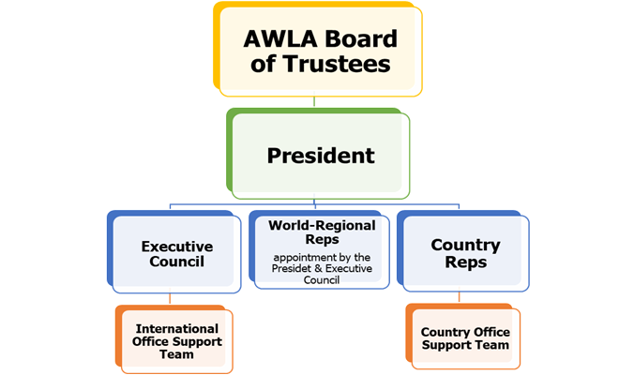

*AWLA Organogram*

The level of trust, partnership and growth that AWLA achieves and commands depends on its internal workable harmony, how it does things and how its operations are viewed and/or interpreted

1. Funding Partnership and Opportunities

Every nonprofit organization must understand that funding is institutional more than it is about proposing a project for funding. If AWLA must attract funding support and partnership across its operations in Africa, it must first institutionalize and bring the requisite technical know-how, organizational prowess, financial accountability and transparency to its routines and operations.

To attract institutional funding at any level and from any local or international sources, it must intentionally engage to achieve same. Strategically, AWLA must operate, report its activities, show transparency and engage at the levels required and with the individuals and the groups to so attract funding support/partnership. The first laudable step taken is in articulating a strategic plan. The plan must be and should be followed to the letter for the next 5-years. AWLA must also consider deliberately engaging with groups through advocacy, submitting grant applications in alignment with AWLA’s vision and mission, networking, and symposiums, including the use of fundraising dinners and public/press engagement processes.

1. **Conclusion**

Questions, comments and submissions were taken on:

* social media and website
* reporting
* hierarchy and titles
* AWLA support to country chapters/team members

The facilitator also committed to supporting AWLA members who have other social interventions they are involved in. However, he said such support will have to come through AWLA to be considered irrespective of who, the location and the needs.

The session was concluded with a closing remarks by the President - Mandy Asagba and a vote of thanks by the AWLA Country Representative USA – HRH Olori Olufunmi Oluyede.

Some participants also called for a soon-repeat of the conference to strengthen membership, operations, experience sharing and synergy